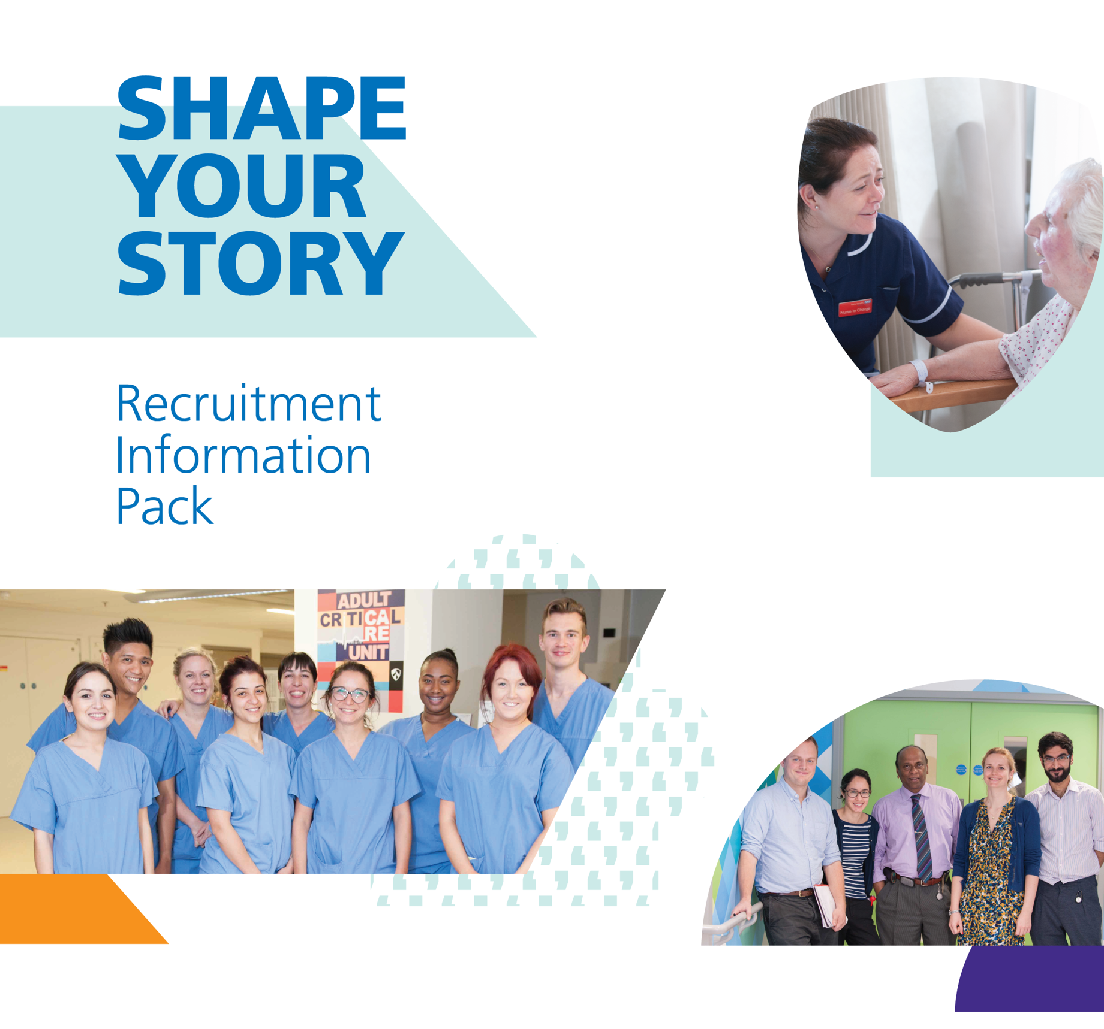

Youth Worker, Royal London Hospital

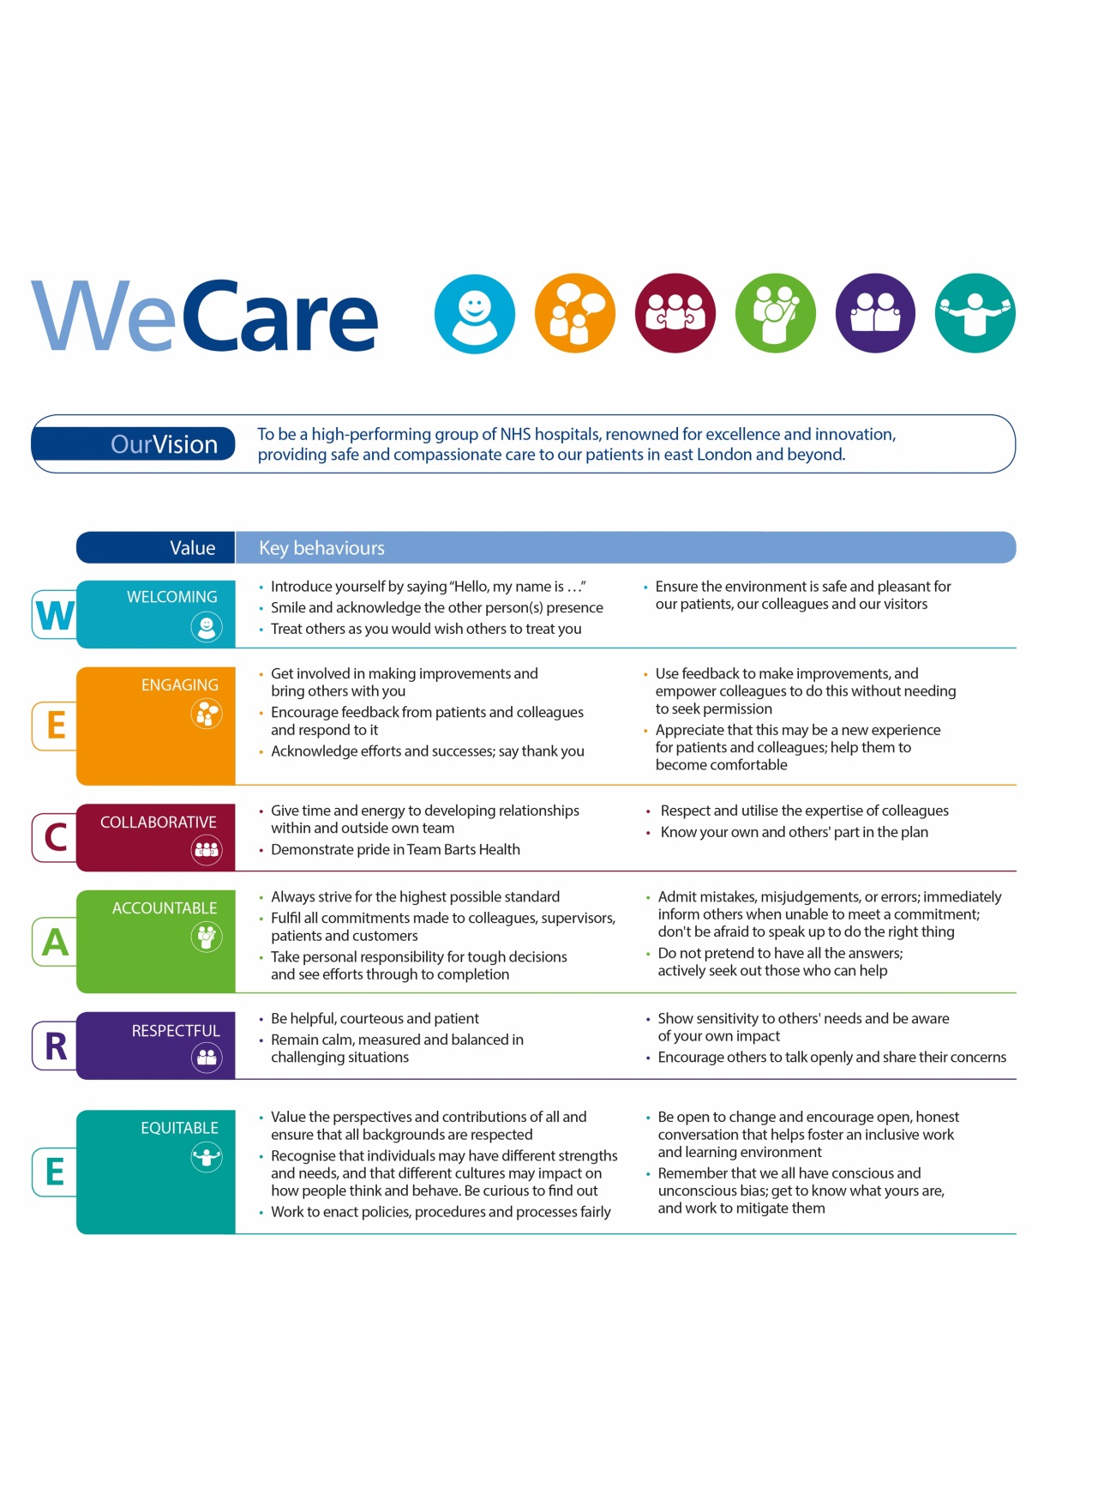

**WeCare about our ambition for excellence**

Our WeCare values shape everything that we do, every single day. They are visible in every interaction we have with each other, our patients, their families and our partners.

WeCare about everything from the appointment letters our patients receive, to the state of our facilities when they walk through the door, to the care and compassion they receive when they are discharged. WeCare that the people who join our trust will hold the same values as we do, so our values are embedded within our recruitment and selection processes. WeCare that you feel valued working here, so our values also guide our training and development and performance and talent management. WeCare about working with suppliers that live and breathe our values too.

We have come a long way on our journey to delivering safe and compassionate care. By embracing these values as the way we behave around here, we will achieve our ambition for excellence.

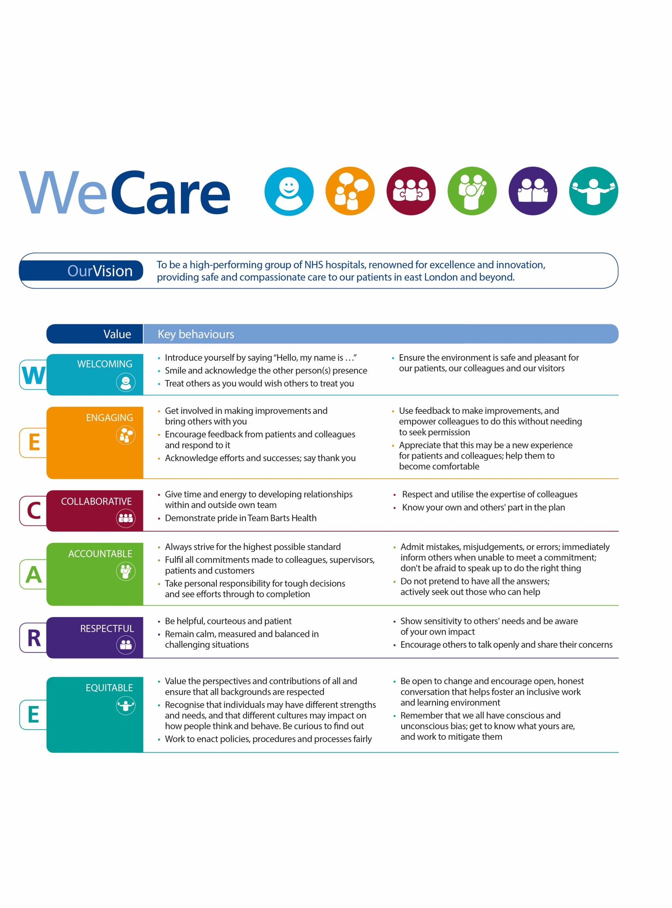

**Job Particulars**

|  |  |
| --- | --- |
| Job Title | Youth Worker |
| Pay Band | Band 5 |
| Location | Royal London Hospital |
| Reports to | Roald Dahl Transition Nurse Specialist, Barts Health |
| Responsible to | Roald Dahl Clinical Nurse Specialist for teenagers and young adults, Barts Health |

1. **Job Purpose**

To improve the services provided to young people on adult wards and adult clinical areas, helping to support clinical teams to support young people in age-appropriate ways. The focussed age group is young people 16 – 19 but in the absence of any young people between these ages the age could be extended to 25.

Working with external agencies to provide appropriate activities and utilise referral pathways both within hospital and the community to meet the needs of this patient group.

1. **Key Working Relationships**

|  |  |
| --- | --- |
| Internal | External |
| Clinical teams | Child and Adolescent Mental Health Services |
| St Giles – Trauma Caseworkers | Mental Health Services |
| Violence Reduction Team | Community Youth Workers |
| After Trauma Care Team | Schools and colleges |
| Hospital Play Specialist Team | General Practitioners |
| Volunteering Service | Social Prescribers |
| Patient Experience Team | Voluntary organisations |
| Teenage and young adult groups |  |

1. **Structure Chart**
2. **Main duties, responsibilities and results areas**

* Act as an advocate for young people on adult wards, ensuring they remain engaged with health services, and provide feedback to clinicians on young people’s views of the service. To encourage young people to self-advocate or advocate on their behalf; working closely with relevant services such as PALS.
* Use the HEEADSSSS tool as the young person’s psychosocial assessment tool of choice. Using these results, work closely with the healthcare team in establishing an appropriate response to support these young people throughout the service.
* Work with the clinical teams to develop an age-appropriate service for young people at the Royal London Hospital, by embedding a culture of listening to young people through involving service users at every level of care and drawing on the expertise of professionals already involved in the care of young people throughout the Trust.
* Attend relevant team meetings at the Royal London Hospital, working with other members of the MDT to engage young people.
* Aid the teams in identifying young people who are or may be at risk of becoming disengaged with their Health care issue/medical team.
* Ensure information resources such as client forms, databases and contact files are kept fully up-to-date and secure, in line with the Data Protection Act and our Confidentiality Policy and Consent Policy.
* Maintain a good level of professional knowledge of the issues affecting young people, particularly related to their health.
* Actively research and network with other organisations working with young people in the local area to ensure that the organisation as a whole has a good knowledge of other services and projects that may be of interest to the young people we work with or appropriate for us to refer to.
* Promote the services that are available within the teenage and young adult page on WeShare
* Actively participate in staff meetings, session evaluations, supervision and reviews, planning sessions and appropriate training. Feed back to managers on the needs of young people, ideas for new projects, and the ongoing development of existing projects.
* Encourage and enable young people to participate in all forms of decision-making and management, with the ultimate aim of empowering them to shape the services and activities provided for them.
* To document and report any concerns relating to needs assessment and safeguarding issues as appropriate.
* To participate in multidisciplinary meetings, reviews etc. providing professional advice on adolescent issues, reporting any relevant information or concerns as necessary, making referrals and maintaining appropriate links.
* Participation in clinical audit, health and safety, quality assurance, risk assessment, bench marking, evaluating user satisfaction, the development of clinical guidelines or protocols, Trust and departmental policies as required is undertaken.
  + To provide advice & education to healthcare professionals on the needs of young people.
  + To identify suitable approaches, appropriate methods and resources to support young people.
* Participate in continuing development to develop the knowledge and skills required for the post.

Undertake mandatory training.

Monitor and reflect on own performance, identifying and addressing own professional needs through regular supervision sessions.

1. **Working conditions**

|  |  |
| --- | --- |
| Criteria | Description |
| Physical | Moving equipment which may include distraction activities on all shifts.  Setting out the activities for young people.  Accompanying and supporting young people to different settings in the absence of parent.  Cleaning and maintenance of recreational equipment daily.  Providing activity and stimulation in young people friendly settings eg. waiting rooms |
| Emotional | Potential for exposure to frustrated and angry patients.  Encouraging peer support.  Discussing and assessing psychosocial wellbeing with young people at every contact. |
| Working Conditions | The nature of the non-clinical duties will require the job holder to be involved in occasional exposure to unpleasant or highly unpleasant working conditions. |
| Mental | Planning programmes of activity designed to meet each individual’s developmental milestones.  Liaise with various agencies to develop relationships with the different centres. Create collaborative projects with other youth workers.  Using risk assessments within project work appropriately |

**Safeguarding adults and children**

Employees must be aware of the responsibilities placed on them to maintain the wellbeing and protection of vulnerable children and adults.  If employees have reason for concern that a patient is 'at risk' they should escalate this to an appropriate person i.e. line manager, safeguarding children's lead, matron, ward sister/change nurse, site manager, consultant (October 2002). [www.nmc-uk.org/](http://www.nmc-uk.org/)

**Person Specification**

|  |  |  |
| --- | --- | --- |
| Domain | Essential Criteria | Desirable Criteria |
| Qualifications | Graduate in either Diploma or Degree qualification in Youth Work |  |
| Experience | Experience of working with young people in a range of activities and settings  Experience of working as an effective team member  Experience of working within a multi-disciplinary team  Experience of working autonomously  Experience of piloting or developing a project or service | Working with young people in a health and well-being context  Working in a London borough  Working in schools, health or criminal justice  Delivering training either in person or virtually |
| Knowledge | A thorough knowledge and understanding of the physical, social and emotional developmental needs of young people  Understanding of the issues faced by young people living in inner city areas  An awareness of child safeguarding issues and knowledge of current best practice within the youth work sector  A knowledge of best practice in case recording | The AMBIT model, solution-focused brief therapy or a similar counselling methodology  Detailed understanding of health-related issues such as self-harm, drugs, smoking, diet, sleep, sexual health, STI screening  Awareness of the HEEADSSSS tool |
| Skills | Well-developed verbal and written communication skills, and an ability to interact with energy and enthusiasm with both young people and adults on a one to one basis and in small groups, within a range of contexts  Ability to plan and manage own workload  Accurate data entry and record keeping and monitoring processes  Ability to use up to date IT systems |  |
| Other | Self-motivated and committed to personal development  Flexible and committed  Effective time management skills and an ability to prioritise tasks and work flexibly to deadlines  A commitment to and understanding of equal opportunities |  |

**About Barts Health**

Our group of hospitals provide a huge range of clinical services to people in east London and beyond.

We operate from four major hospital sites (The Royal London, St Bartholomew’s, Whipps Cross and Newham) and a number of community locations, including Mile End hospital. Around 2.5 million people living in east London look to our services to provide them with the healthcare they need.

The Royal London in Whitechapel is a major teaching hospital providing local and specialist services in state-of-the-art facilities. Whipps Cross in Leytonstone is a large general hospital with a range of local services. Newham in Plaistow is a busy district hospital with innovative facilities such as its orthopaedic centre. Mile End hospital is a shared facility in Mile End for a range of inpatient, rehabilitation, mental health and community services. And St Bartholomew’s in the City, London’s oldest hospital, is a regional and national centre of excellence for cardiac and cancer care.

As well as district general hospital facilities for three London boroughs, Tower Hamlets, Waltham Forest and Newham, we have the largest cardiovascular centre in the UK, the second largest cancer centre in London, an internationally-renowned trauma team, and the home of the [London Air Ambulance](https://londonsairambulance.co.uk/). The Royal London also houses one of the largest children’s hospitals in the UK, a major dental hospital, and leading stroke and renal units.

We're also proud to be part of [UCLPartners](http://www.uclpartners.com/), Europe’s largest and strongest academic health science partnership. The objective of UCLPartners is to translate cutting edge research and innovation into measurable health gain for patients and populations through partnership across settings and sectors, and through excellence in education.